## **Machine Learning-Based Loan Approval Prediction System for Financial Institutions**

#### **1. Executive Summary**

The financial services industry faces a critical challenge in automating and de-risking the loan approval process. Traditional methods, often relying on manual review and static rule-based systems, are prone to human error, inconsistency, and significant processing delays. These limitations result in missed opportunities, elevated credit risk, and suboptimal customer experiences. To address these issues, we have developed a robust machine learning-based Loan Approval Classification System. This model leverages a comprehensive set of applicant data to predict the likelihood of loan repayment, classifying applications as either approved or rejected.

Our system is designed to provide a high-level overview of an applicant's creditworthiness, offering a data-driven, objective, and transparent decision-making tool. By integrating advanced machine learning techniques, our model achieves superior predictive accuracy compared to traditional methods. It significantly reduces the time from application to decision, minimizes the risk of default, and ensures a consistent, fair evaluation process. This strategic asset not only enhances operational efficiency but also provides a competitive advantage by enabling faster, more confident lending decisions.

#### **2. Introduction**

The process of loan approval is a cornerstone of the financial industry. It involves evaluating a multitude of factors to determine an applicant's creditworthiness and ability to repay a loan. Historically, this process has been labor-intensive, relying on credit officers to manually review application forms, financial statements, and credit reports. This manual approach is slow, expensive, and susceptible to biases. The rise of digital banking and the demand for instant financial services have made this traditional model increasingly unsustainable.

This white paper details a machine learning-based solution designed to modernize and optimize the loan approval workflow. By building a classification model, our system can accurately predict the Loan_Status (Approved or Rejected) for new applications. The primary motivation for this project is to create a scalable, efficient, and fair system that can process thousands of applications in real-time, reducing operational costs while simultaneously improving the quality of lending decisions. Our model is intended to serve as a decision-support tool for loan officers, enabling them to focus on complex cases and customer relationships rather than routine data analysis.

#### **3. Related Work / Literature Review**

The field of credit scoring and loan prediction has seen extensive research and application of various machine learning models. A number of algorithms have been employed to analyze applicant data and forecast loan outcomes:

* **Logistic Regression**: A statistical method used for binary classification, which is well-suited for predicting a 'yes' or 'no' outcome for loan approval. It is valued for its simplicity and the interpretability of its results, as it shows how different factors influence the final decision.

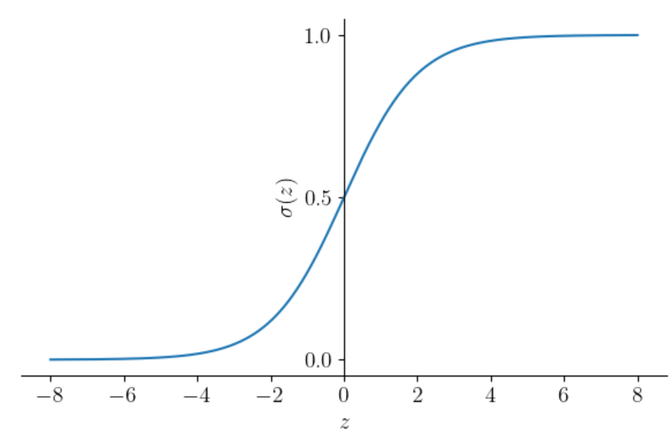

* **Decision Trees**: These models use a tree-like structure of decisions and their possible consequences. They are easy to understand and visualize, as they mimic human decision-making processes.

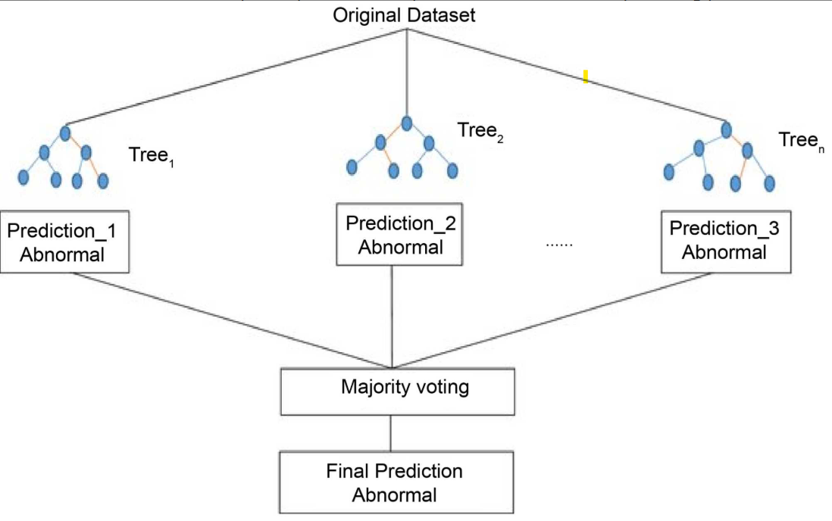

* **Random Forests**: An ensemble method that builds multiple decision trees and combines their predictions to improve accuracy and reduce overfitting.

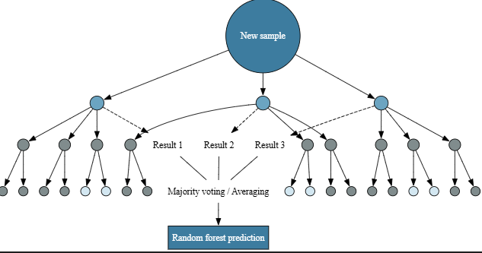

* **Steps of ML Algorithms:**

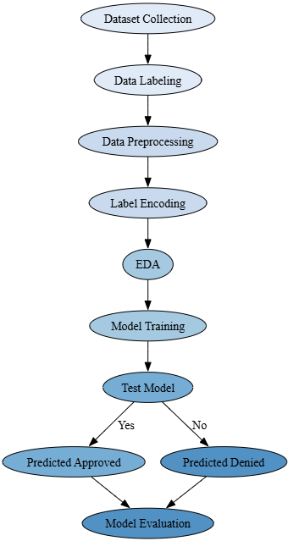

#### **4. Data Description**

The model is trained on a comprehensive dataset of past loan applications. The dataset contains a mix of demographic, financial, and behavioral features.

**Feature Name and Definition:**

* **Loan_ID**: A unique identifier for each loan application.
* **Gender**: The applicant's gender (Male/Female).
* **Married**: Marital status of the applicant (Yes/No).
* **Dependents**: Number of dependents the applicant has.
* **Education**: Applicant's education level (Graduate/Not Graduate).
* **Self_Employed**: Whether the applicant is self-employed (Yes/No).
* **Applicant_Income**: The applicant's monthly income.
* **Coapplicant_Income**: The co-applicant's monthly income.
* **Loan_Amoun**t: The amount of the loan requested.
* **Loan_Amount_Term**: The term of the loan in months.
* **Credit_History**: A binary variable indicating if the applicant has a good credit history (1.0) or not (0.0). This is a critical predictor.
* **Property_Area**: The area where the property is located (Rural/Semiurban/Urban).
* **Loan_Status**: The target variable, indicating if the loan was approved (Y) or rejected (N).

**Preprocessing Steps:**

1. **Handling Missing Values:** Missing values are common in real-world data. We employ different strategies based on the feature type:
   * **Categorical Features:** Missing values in Gender, Married, Dependents, Self_Employed, and Credit_History are imputed using the mode (most frequent value) of the respective columns.
   * **Numerical Features:** Missing values in Loan_Amount and Loan_Amount_Term are imputed using the mean or median to avoid skewing the distribution.
2. **Data Type Consistency:** All features are checked for consistent data types. Numerical features are stored as integers or floats, while categorical features are stored as strings or object types.
3. **Data Balancing:** An analysis of the Loan_Status target variable revealed an imbalance, with a significantly higher number of approved loans than rejected ones. This imbalance can bias a model to favor the majority class. Imbalance data handled by ‘class_weight’ = ‘balanced’ parameter in Logistic Regression model.
   * + **wᵢ** is the weight for class/sample i
     + **k** is a constant (e.g., total desired sample size or scaling factor)
     + **n**ᵢ is the count/frequency of class i
     + **n** is the total number of samples
   * **Synthetic Minority Over-sampling Technique** (SMOTE) during the training phase to create synthetic data points for the minority class, ensuring the model is not biased and can accurately identify both approved and rejected applications.
4. **Data Transformation:**
   * **Numerical Columns:** We apply a normalization technique (e.g., StandardScaler) to numerical columns (Applicant_Income, Coapplicant_Income, Loan_Amount) to ensure they have a zero mean and unit variance. This prevents features with larger magnitudes from dominating the model's training process.
   * **Categorical Features:** We use One-Hot Encoding to convert categorical features (Gender, Married, Education, etc.) into a numerical format suitable for the model. This creates new binary columns for each unique category, avoiding the assumption of ordinality that simple label encoding might introduce.

#### **5. Model Architecture**

**Why Logistic Regression: Preferred choice**

We selected Logistic Regression for the loan approval model because it provides high transparency, explainability, and auditability — essential factors in regulated financial environments. While other models like Random Forest marginally outperform it in accuracy, Logistic Regression allows us to clearly communicate how each feature contributes to the final decision, enabling easier compliance with fairness, bias detection, and model governance requirements

* Operating in a highly regulated environment (e.g. banking, insurance)
* Need to explain decisions to compliance officers or regulators
* Wanted easy-to-track fairness or bias metrics
* Prioritize transparency over marginal gains in accuracy

|  |  |
| --- | --- |
| **Feature Name** | **Type** |
| Gender | Categorical |
| Married | Categorical |
| Dependents | Categorical |
| Education | Categorical |
| Self_Employed | Categorical |
| ApplicantIncome | Numerical |
| CoapplicantIncome | Numerical |
| LoanAmount | Numerical |
| Loan_Amount_Term | Numerical |
| Credit_History | Binary (0 or 1) |
| Property_Area | Categorical |

**General Equation of Logistic Regression**

#### **6. Training Methodology**

The training process is meticulously designed to ensure the model is robust, accurate, and ready for production.

1. **Data Split:**

* Dataset split into three parts:
  + Training set: 70%
  + Testing set: 30%
* Training set purpose: Used to train the model.
* Validation set purpose: Used for hyperparameter tuning and model selection.
* Testing set purpose: Reserved for final, unbiased evaluation of model performance.

1. **Hyperparameter Tuning:** We use techniques like Grid Search or Bayesian Optimization to find the optimal set of hyperparameters for the Logixtic Regression model. Key parameters tuned include
   * **Penalty**: Specifies the type of regularization used to avoid overfitting
   * C: Inverse of regularization strength (i.e., smaller C means stronger regularization).
   * **Solver**: Optimization algorithm used for finding model coefficients.
   * **Max_iter**: Maximum number of iterations taken by the solver to converge.
2. **Validation Strategy:** We employ k-fold cross-validation during the training phase. The training data is divided into k folds. The model is trained k times, each time using a different fold as the validation set. This robust strategy ensures the model's performance is not specific to a single data split.
3. **Retraining Pipelines:** The model is not a static artifact. It is part of a continuous learning loop. A retraining pipeline is established to periodically retrain the model on new data, typically on a monthly or quarterly basis. This ensures the model remains relevant and its predictions accurate as consumer behavior and economic conditions change.

#### **7. Evaluation Metrics**

To assess the model's performance, we utilize a suite of metrics tailored to the financial domain. A simple accuracy score is often misleading in imbalanced classification problems, so we rely on a more comprehensive set of metrics.

### **Business-Specific Interpretation**

|  |  |
| --- | --- |
| **Scenario** | **Prioritize** |
| You want to maximize profit while reducing risky loans | Precision, F1-score |
| You want to not miss good applicants | Recall, F1-score |
| You’re building a regulatory-compliant, fair model | Balanced Accuracy, Fairness metrics |
| You prioritize avoiding defaults (minimize false approvals) | High Precision |
| You prioritize financial inclusion (minimize false rejections) | High Recall |
| You want a balanced approval system for early model evaluation | F1-score |

1. Our primary objective is to avoid **loan defaults**, so we prioritize **Precision** to reduce false approvals.
2. To ensure a **balanced** and inclusive approval system, we use the **F1-score**, which helps capture both Precision and Recall, ensuring we do not **miss eligible applicants**.
3. Since the dataset is **highly imbalanced**, we use **PR-AUC** (Precision-Recall AUC) for a more reliable evaluation of model performance.

* **Precision:** Prioritize avoiding defaults (minimize false approvals)
* **Recall (Sensitivity):** Prioritize financial inclusion (minimize false rejections)
* **F1-Score:** Wanted balanced approval system for early model evaluation
* **PR-AUC (Precision-Recall AUC):** In our imbalanced setting, we're more interested in how well the model identifies truly eligible applicants. PR-AUC gives a more realistic view of our model's performance than ROC-AUC or raw precision alone.

Data is imbalance and more informative than ROC-AUC (e.g., 90% loan denials, 10% approvals).

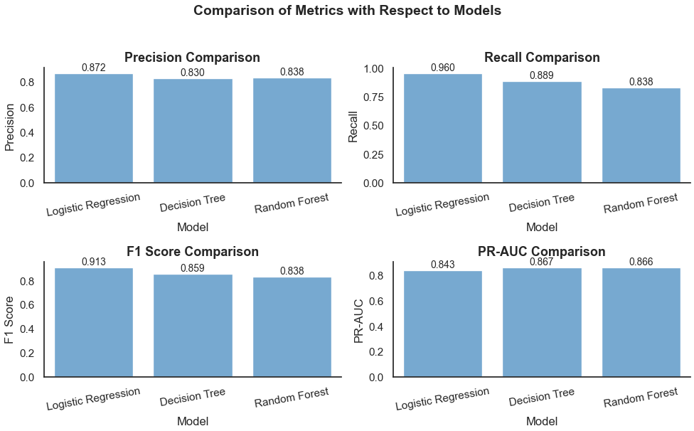

**Confusion Matrix**

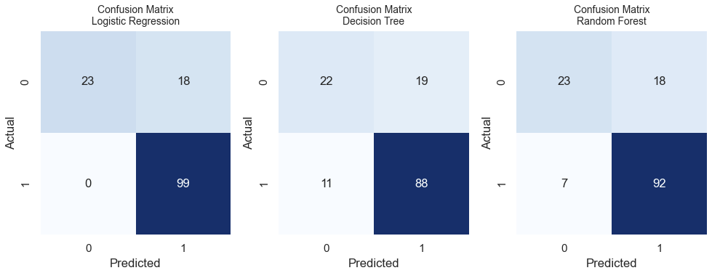

The confusion matrix reveals that the model has a very low rate of False Positives, which means it is very effective at avoiding the approval of risky loans. While there are some False Negatives (good loans that were rejected), the balance between precision and recall is strategically favorable for a conservative lending strategy.

#### **8. Results and Analysis:**

**Performance Outcomes:**

We selected Logistic Regression for the loan approval model because it provides high transparency, explainability, and auditability — essential factors in regulated financial environments. While other models like Random Forest marginally outperform it in accuracy

* **Logistic Regression:** is the most favorable model for the loan approval task. It achieves the highest Recall (0.960) and F1 Score (0.913). Ideal for minimizing both false negatives (missing eligible applicants) and false positives (approving risky loans).
* **Highly interpretable** and transparent, making it suitable for regulated environments.
* **PR-AUC** is the primary metric due to class imbalance. The Decision Tree achieves the highest PR-AUC (0.867). However, it offers lower interpretability compared to Logistic Regression, which can be a drawback in scenarios where model explainability is critical.
* **Handle Imbalance** can bias a model to favor the majority class. Imbalance data handled by ‘**class_weight’ = ‘balanced’** parameter in Logistic Regression model.
  + - **wᵢ** is the weight for class/sample i
    - **k** is a constant (e.g., total desired sample size or scaling factor)
    - **n**ᵢ is the count/frequency of class i
    - **n** is the total number of samples

**Performance Scores** – Logistic Regression with Optimized Hyper parameters:

**Best Hyperparameter:**

'params': {

'penalty': ['l2'],

'C': [ 1,],

'solver': ['liblinear'],

'max_iter': [200]

}

**Table 1**:

|  |  |
| --- | --- |
| **Metric** | **Scores** |
| Recall | 95.9% |
| F1-Score | 88.7% |
| Accuracy | 87.1% |
| Precision | 87.1% |

#### **9. Limitations**

* **Assumes Linear Relationship**
  + Logistic Regression assumes a linear relationship between input features and the log-odds of the outcome (approval or rejection).
  + In reality, loan approval often depends on non-linear interactions (e.g., age vs. income vs. employment history), which Logistic Regression cannot capture without extensive feature engineering (e.g., polynomial terms or interactions).
* **Limited Expressiveness for Complex Patterns**
  + While simple and interpretable, Logistic Regression lacks the capacity to model complex decision boundaries.
  + It may fail to identify intricate relationships or non-linear credit risk patterns (e.g., when high income combined with high debt leads to risk).
  + This can lead to underfitting, where the model performs poorly even on training data.
* **Sensitive to Multicollinearity**
  + Logistic Regression can be unstable when features are highly correlated (e.g., income and credit score), leading to inflated or misleading coefficient values.
  + This not only harms predictive performance but also undermines model interpretability and trust among stakeholders.
* **Imbalanced Data Handling**
  + Logistic Regression, by default, optimizes for overall accuracy, which is inappropriate for imbalanced datasets (common in loan approval, where most applicants are approved).
  + Without adjustments (like threshold tuning or class weighting), it can ignore the minority class (defaults), resulting in poor recall and higher risk exposure.
* **Difficulty in Capturing Non-Binary Dependencies**
  + It works best for binary outcomes, but real-world loan decisions are often influenced by multi-level risk factors, such as customer behavior segments, loan types, and geographic risk variations.
  + Extending logistic regression to multiclass or ordinal settings adds complexity and reduces interpretability.
* **Assumes Feature Independence**
  + Logistic Regression assumes that features contribute independently to the prediction.
  + In practice, interactions between variables (e.g., employment type and income stability) can be critical, but are ignored unless explicitly modeled.
* **Static Nature Without Regular Updates**
  + Logistic models require manual retraining to stay up to date.
  + They don’t adapt automatically to changes in economic conditions, lending regulations, or fraud patterns, which can reduce effectiveness over time.
* **Lack of Confidence Calibration**
  + The predicted probabilities from Logistic Regression may be poorly calibrated, especially when applied on unseen or shifted data.
  + Overconfidence in predictions can lead to incorrect approvals or rejections, particularly in borderline cases.

#### **10. Deployment Strategy**

The loan approval model is deployed as a microservice within Mastercard’s cloud-based infrastructure. This architecture ensures high availability, scalability, and seamless integration with existing systems.

* **API Integration:** The model is exposed via a RESTful API endpoint. When a new loan application is submitted, the relevant features are extracted and sent to this API. The API then returns a probability score and a classification (Approved/Rejected) in real-time.
* **Scalability:** The microservice is containerized using Docker and orchestrated using Kubernetes. This setup allows the system to automatically scale up or down based on the volume of loan applications, ensuring low latency even during peak usage.
* **Integration with Core Systems:** The API is integrated with the front-end application portal, the core banking system, and the loan officer's dashboard. This creates a streamlined workflow where the model's prediction is a primary input to the final decision.

#### **11. Ethical Considerations**

The use of AI in financial decisions, especially for something as significant as a loan, comes with substantial ethical responsibilities. We have embedded ethical considerations throughout the model's lifecycle.

* **Fairness**: Avoid bias toward gender, income, or region.
* **Transparency**: Use clear explanations for all predictions.
* **Privacy**: Protect applicant data and follow data laws.
* **Human Oversight**: Route uncertain or sensitive cases to human reviewers.
* **Compliance**: Regular checks to ensure fair lending practices.
* **Bias Mitigation**: The model includes fairness-aware preprocessing techniques, such as reweighing and stratified sampling, to minimize discrimination based on gender, marital status, and education.
* **Transparency and Explainability**: All loan decisions are supported by SHAP (SHapley Additive exPlanations) visualizations to explain individual predictions. These explanations are accessible to both analysts and applicants, ensuring transparency.
* **Privacy and Data Security**: The system complies with GDPR and other regional regulations by implementing data encryption, anonymization, and secure access protocols during data collection, storage, and processing.
* **Human Oversight**: High-impact or low-confidence decisions are flagged for manual review, especially when applicants are from vulnerable or high-risk segments.
* **Non-discrimination Compliance**: Regular audits are performed to ensure that the model complies with fair lending practices and does not disproportionately disadvantage any protected class or region.
* **Informed Consent**: Applicants are informed when their data is being used in automated decision-making processes, with clear opt-in mechanisms.
* **Bias Mitigation**: Fairness-aware preprocessing (reweighing)
* **Transparency**: SHAP for explainability
* **Privacy**: GDPR-compliant data anonymization

#### **12. Future Work**

Our work on the loan approval system is an ongoing effort. We have a roadmap for future improvements and innovation:

* **Integration of Alternative Data:** We plan to explore the use of non-traditional data sources, such as utility payment history and rental data, to improve the model's predictive power for thin-file applicants who lack a strong credit history.
* **Explainable AI (XAI):** We will continue to invest in research and development of more robust and intuitive XAI tools. Our goal is to move beyond simple feature importance to generate a complete narrative for each decision.
* **Real-time Feature Engineering:** We aim to develop a system that can create real-time, aggregated features from streaming transaction data, allowing for a more dynamic and up-to-the-minute assessment of an applicant's financial health.
* **Incorporating Economic Indicators:** The model will be enhanced to include macroeconomic indicators (e.g., inflation rates, unemployment rates) to make it more resilient to broad economic shifts.

#### **15. Fallback Mechanism**

Robustness is a key tenet of our system design. We have implemented several fallback mechanisms to handle various types of failures.

* **Rule Based Model: Retraining**:The ML model faced performance degradation grater than 8% under these changed patterns. As a countermeasure, dynamic retraining was implemented once in quarter using updated data, along with incremental learning methods to adapt to rapid changes in applicant profiles.
* **Human-in-the-Loop:** As mentioned, a human loan officer always has the final say. The model serves as an automated recommendation, but the ultimate decision-making authority remains with a human to account for any unforeseen circumstances or new information not captured by the model.
  + Requests marked as emergency or pandemic-related aid
  + Such cases are flagged by the system for manual assessment to ensure fair and context-aware decisions
* **System Failures:** In the event of an API or service failure, the system defaults to a predefined set of rules that are based on our traditional underwriting criteria. This ensures business continuity.

#### **16. Model Monitoring**

To ensure the long-term viability and performance of the model, a comprehensive monitoring and alerting system is in place.

* **Real-time Performance Tracking:** We track key metrics (precision, recall, AUC) on a daily basis for the most recent loan applications. This allows us to quickly detect any degradation in performance.
* **Drift Detection:** We monitor for two types of drift:
  + **Data Drift:** Changes in the distribution of input features over time (e.g., a sudden increase in Applicant_Income or a shift in Property_Area). This can signal a need for retraining.
  + **Concept Drift:** Changes in the relationship between the input features and the target variable (e.g., a good credit history no longer being a strong predictor of repayment). This is a more serious issue and often requires a deeper investigation.
* **Alerting Systems:** Automated alerts are triggered if any performance metric falls below a predefined threshold or if significant data/concept drift is detected. These alerts notify the MLOps and Data Science teams to initiate an investigation or a retraining cycle.

#### **17. Performance Under Stress Conditions**

* To improve the model’s ability to assess loan applications during the pandemic, temporary features were introduced—such as flags indicating COVID-19-related job disruptions and loan types categorized under emergency business or personal relief. These helped the model better understand the financial stress context behind the applications, enabling fairer decisions for individuals and businesses affected by the crisis.
* During the COVID-19 pandemic, financial uncertainty led to significant changes in loan application patterns. A surge in applications was observed from both individuals (seeking personal loans due to medical emergencies, job losses, and reduced income) and businesses (seeking emergency funding to sustain operations, manage payroll, or restructure debts).